Saturday, October 21, 2023
8:00PM

Location
Flato Markham Theatre - 171 Town Centre Blvd

8:00PM
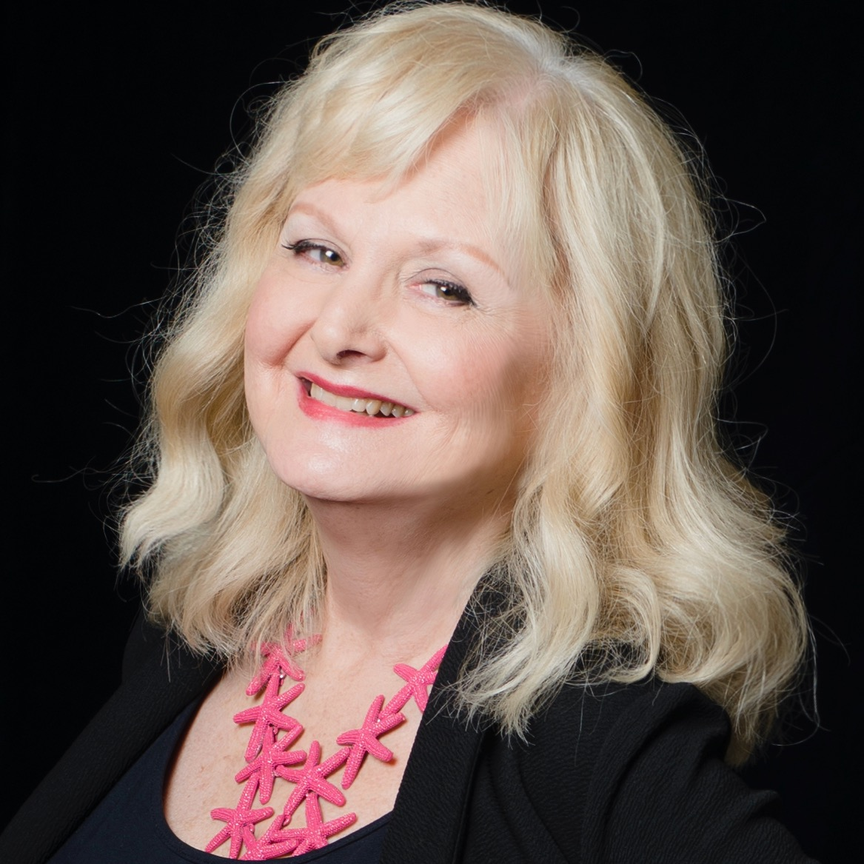

WAR AND PEACE

Opening Night Gala Concert, Christina Petrowska Quilico, piano and the Kindred Spirits Orchestra, Kristian Alexander, conductor
https://ksorchestra.ca/events/war-and-peace/

