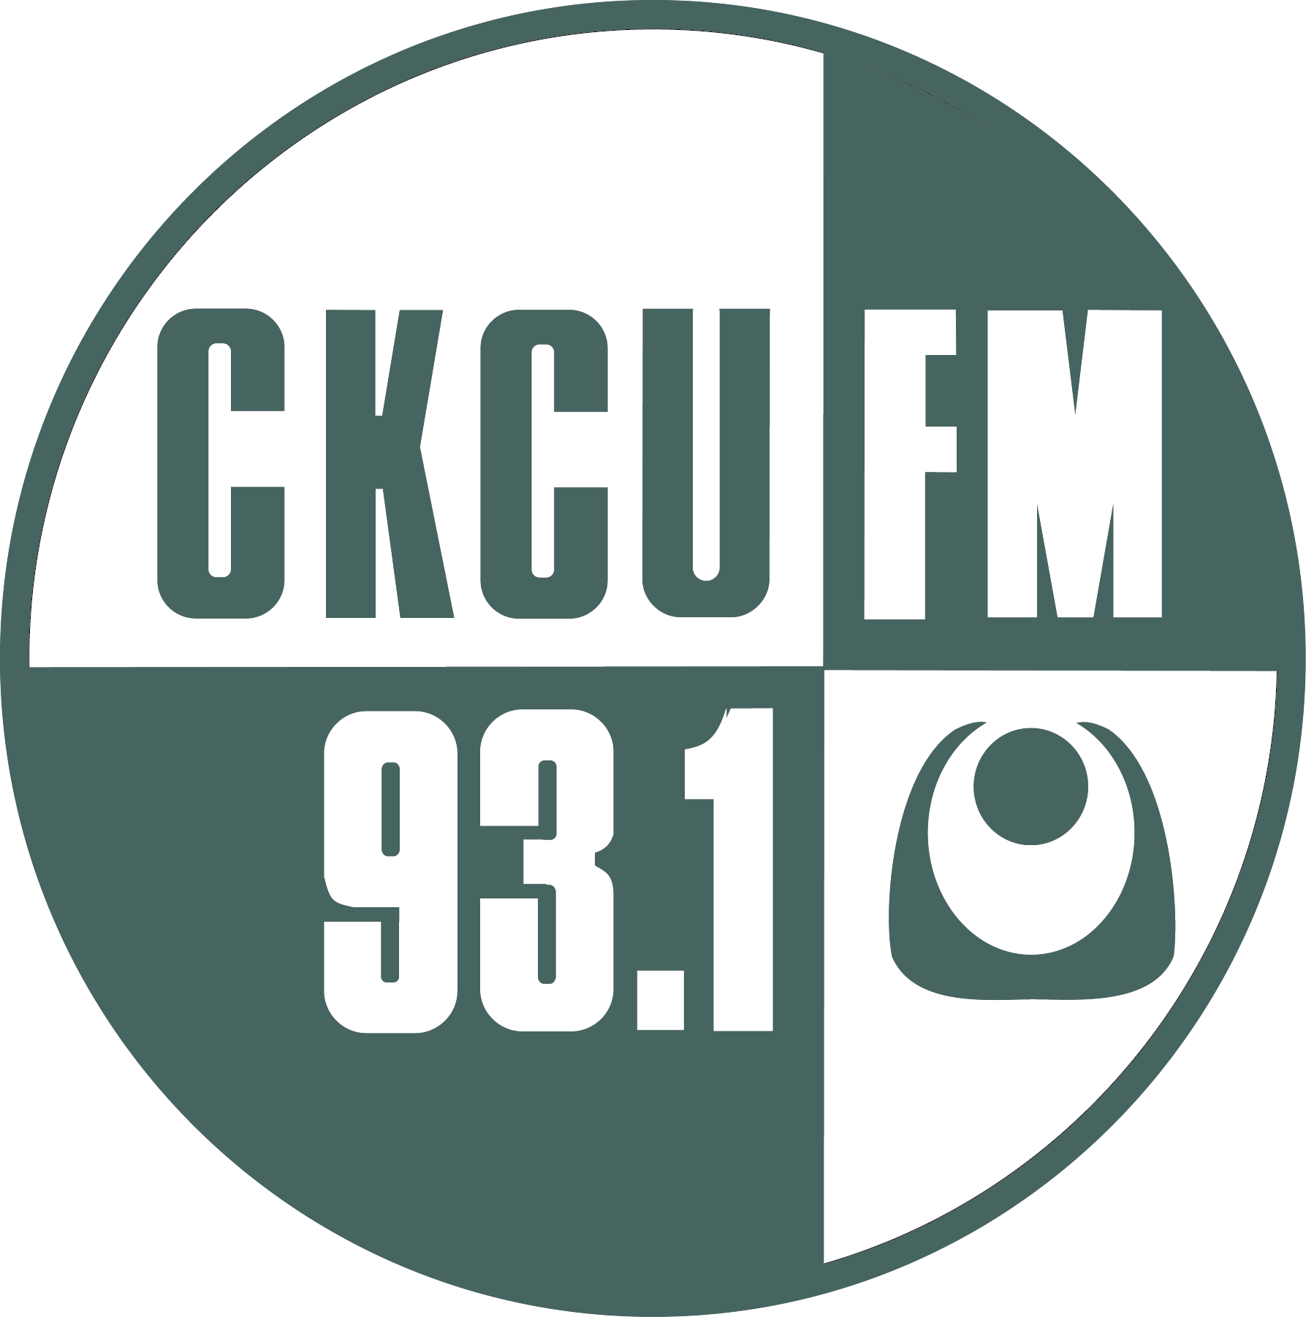 | CKCU FM 93.1



DAVID DALLE
CKCU FM 93.1

Thursday July 4th, 2024 with David Dalle

Games of the Night Wind: guest, Christina Petrowska Quilico, joins me to discuss her new album she is featuring at Music & Beyond.
ABOUT PRIOR PLAYLIST ALL PLAYLISTS SEARCH
Skip to Tracks
Today I am joined by a Canadian musical treasure, pianist Christina Petrowska Quilico. Petrowska Quilico has recently released an album "Games of the Night Wind" featuring twelve new compositions by Canadian composer David Jaeger. These twelve piano pieces are nocturnes, which are interspersed with nocturnes and nocturnal pieces by Toru Takemitsu, Alexandre Tansman, and Heynryk Gorecki. We will discuss this unique, haunting program, which she is presenting at Music & Beyond on Wednesday July 10th. https://musicandbeyond.ca/tc-events/nocturnes/ We will listen to "Games of the Night Wind" and also some other music appearing at the festival.
Speaking with Christina Petrowska Quilico
https://cod.ckcufm.com/programs/105/65906.html

